**Unit 10 seminar preparation – exploration of CNN algorithms**

I read through the CNN explanation in the CNN Explainer platform and explored the computations being performed in the different layers. I also tested uploading a different image to see how the algorithm responded.

**Figure 1 - General layout of the CNN algorithm**

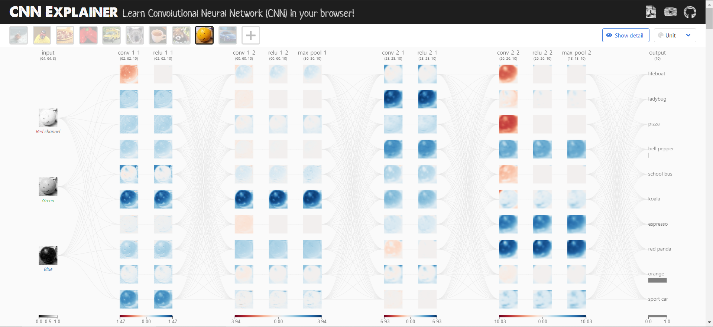

**Figure 2 - Convolutional layers**

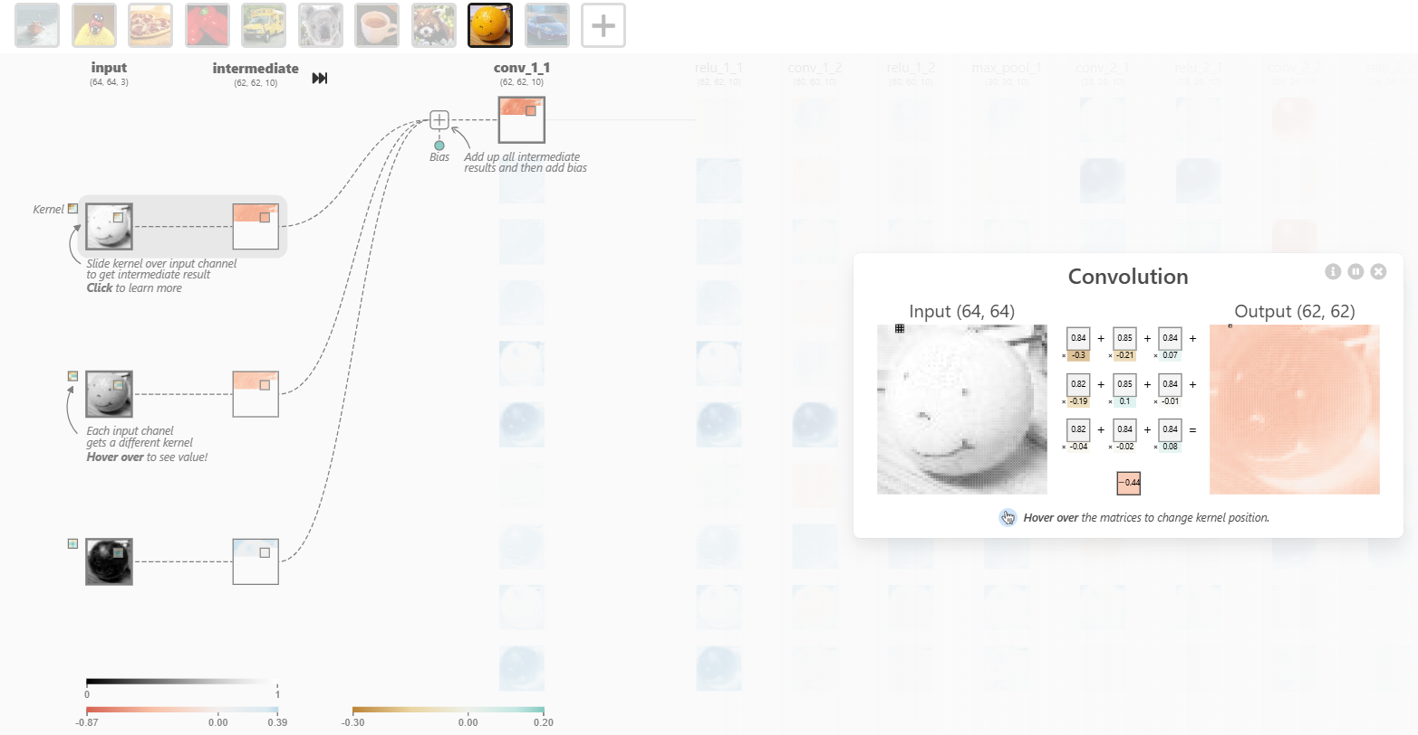

**Figure 3 - ReLU activation layer**

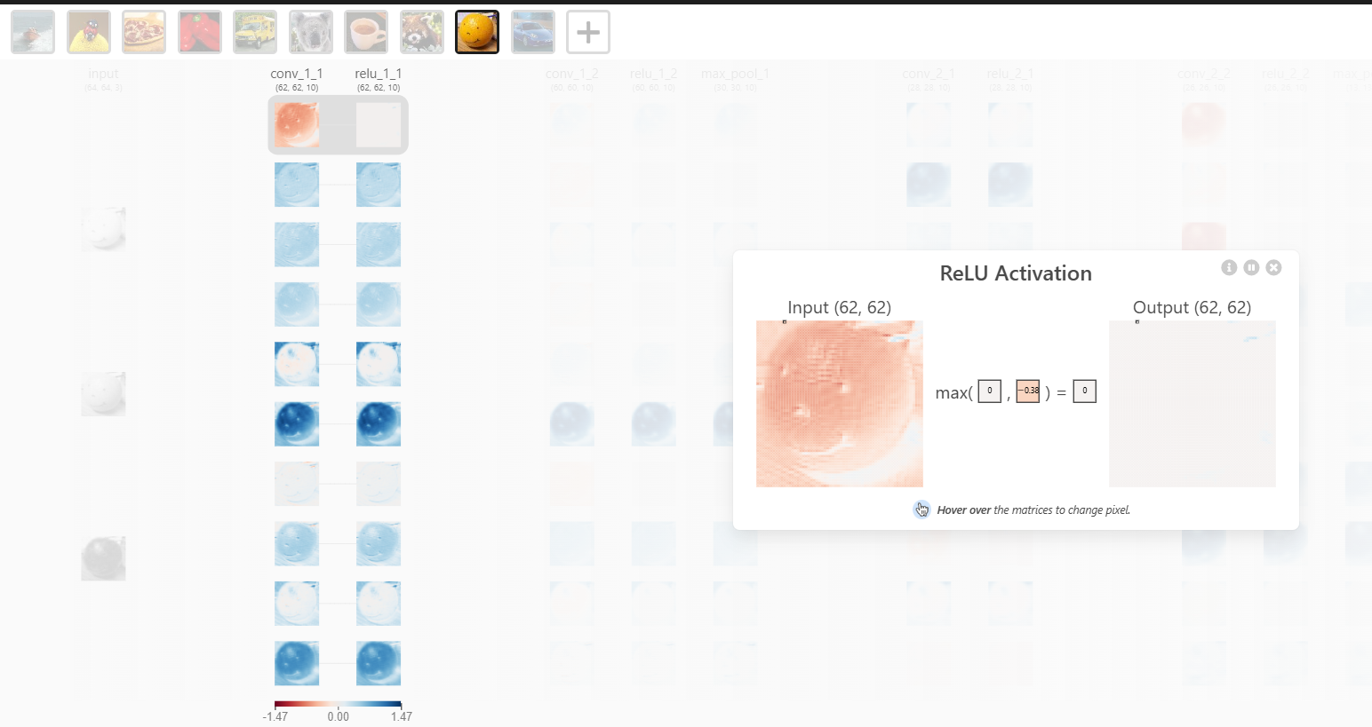

**Figure 4 - Pooling layer**

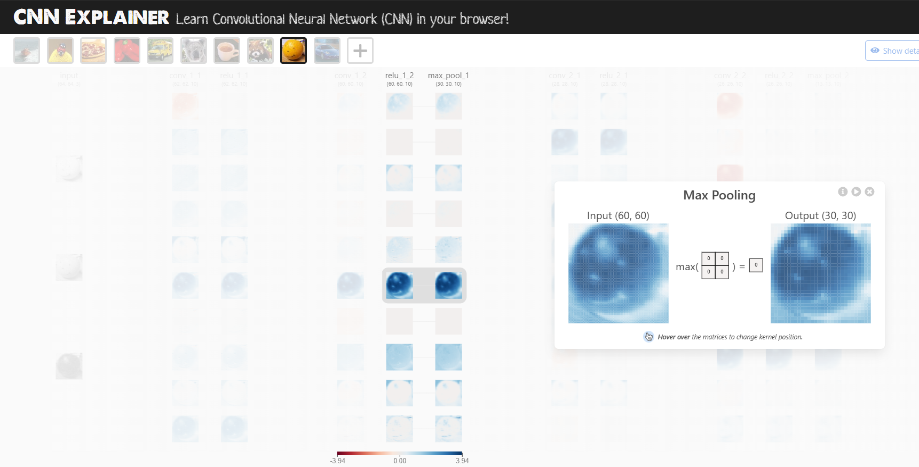

**Figure 5 - Final pooling layer and flattening layer**

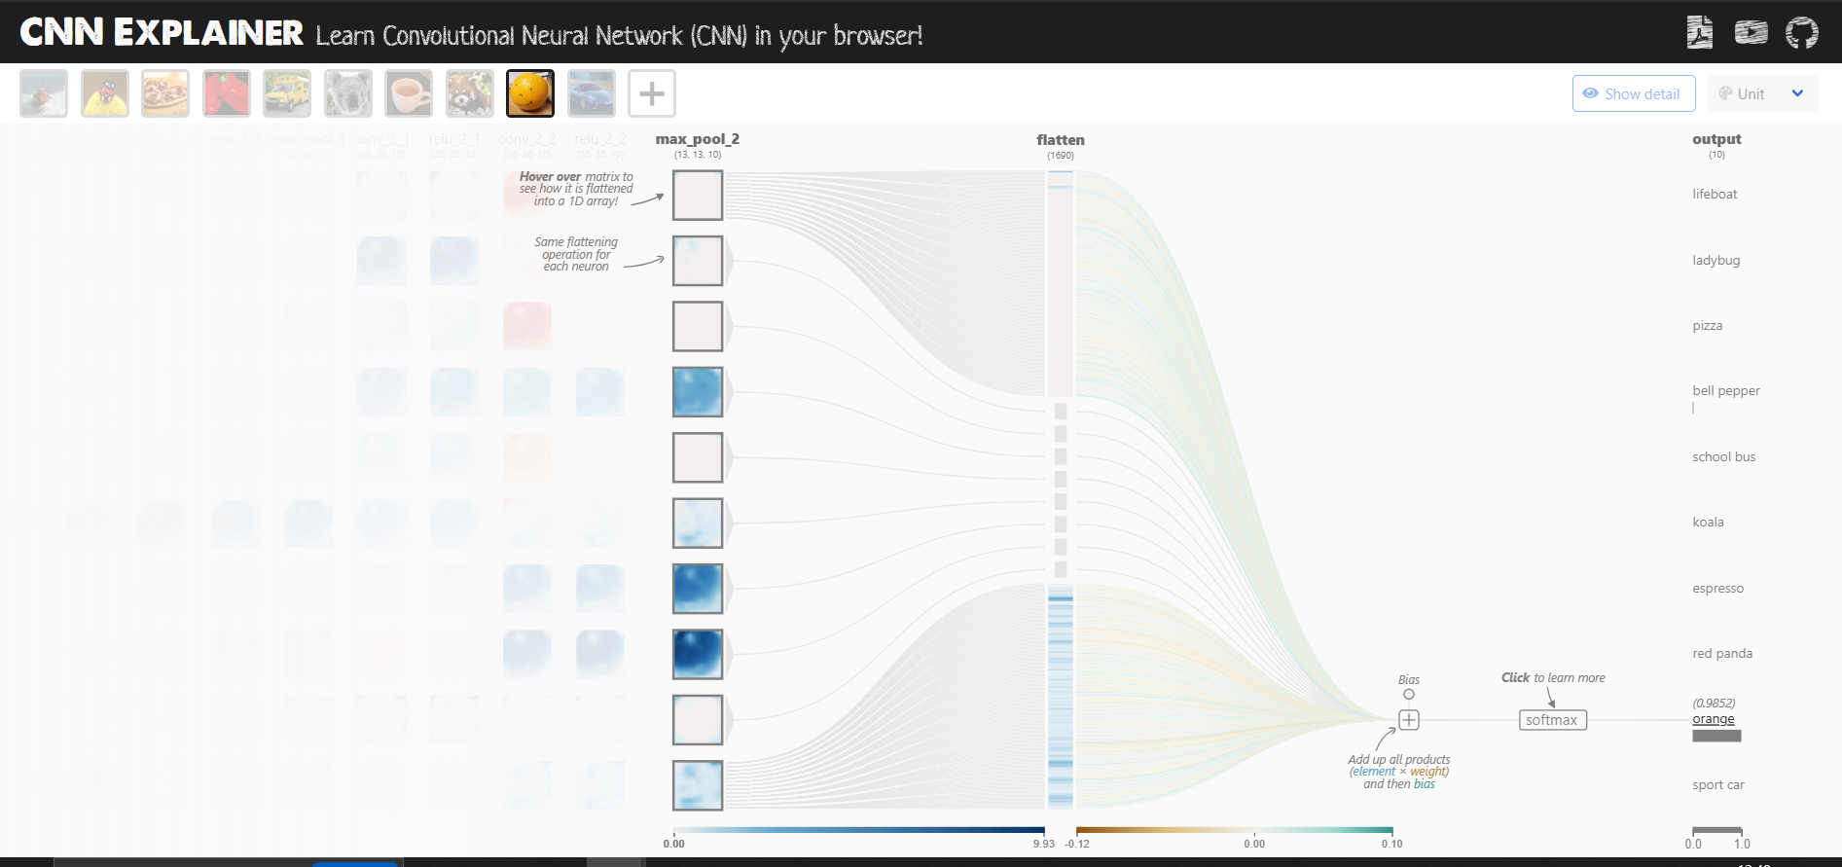

**Figure 6 - Final softmax activation layer**

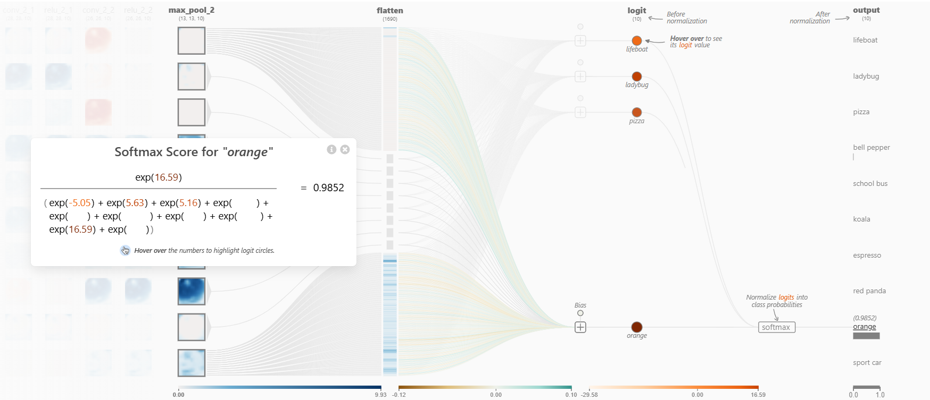

**Figure 7 – New image used for testing (orange)**

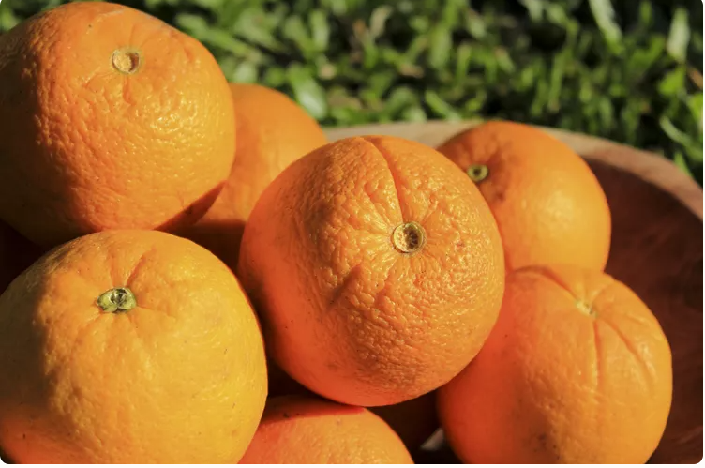

**Figure 8 - Classification results with new image (orange)**

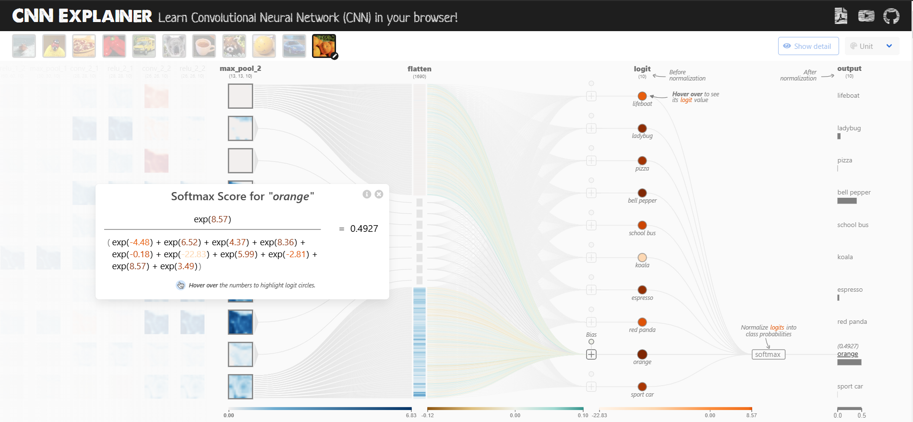

Very close logits found for orange and red pepper. Interesting as the contours in the red pepper image are more similar to the contours in the new orange image (several objects), but the color still stands out

**Figure 9 – New image used for testing (motorbike)**

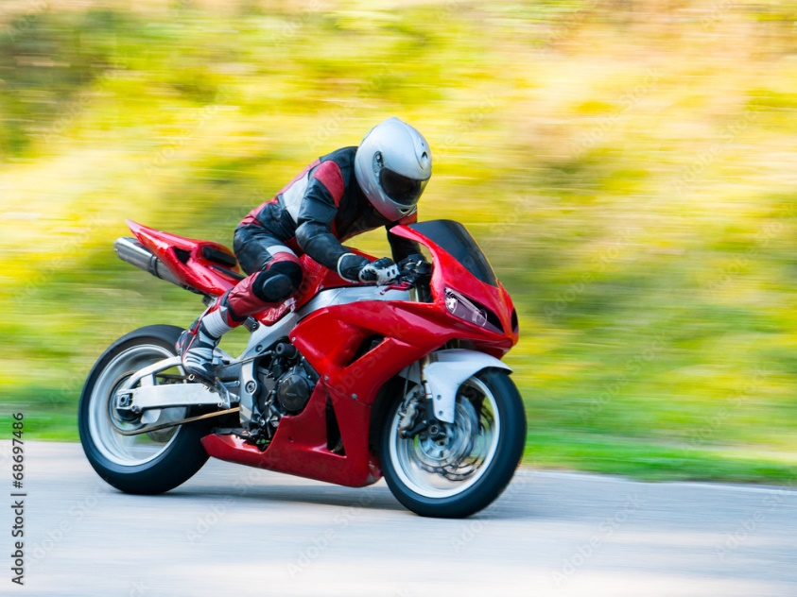

**Figure 10 - Classification results with new image (motorbike)**

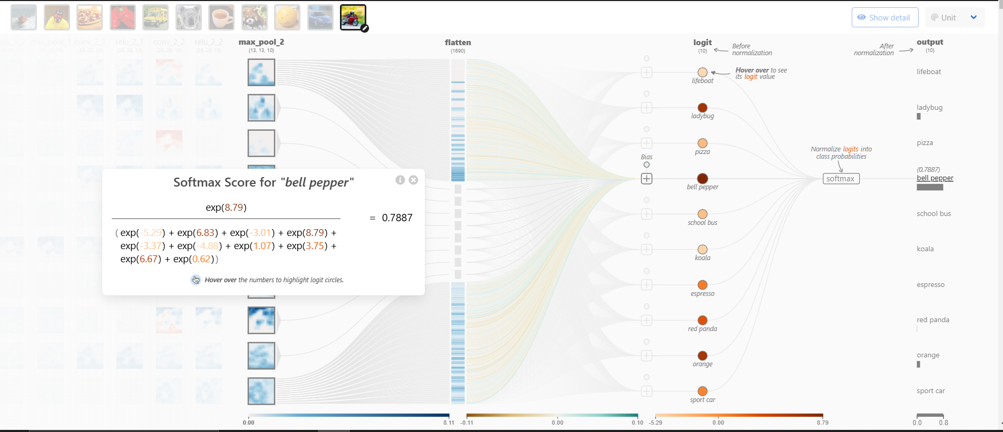

Interesting result – I would expect the algorithm to pick up features such as wheels or the road and attribute a higher score to sports care or school bus, but instead it seemed that it picked up the red colour and the general oblong contours of the red peppers.